COUNTIS E: communicate via Ethernet with Socomec's new energy metres

Benfeld, 3rd April 2017
Multiple communications, MID measurements, compactness, higher-charge currents...When looking at the entire range of COUNTIS E smart metres currently offered by Socomec, it is clear that wide-scope performance goes hand in hand with easy use.

COUNTIS E active and reactive energy metres make high-precision measurements, and provide other electrical parameters essential to energy cost management. Able to conduct direct measurements up to 100 A and up to 6,000 A on current transformers, they meet the needs and constraints of all electrical installations perfectly: industrial sites, healthcare establishments, data centres, infrastructures, high-rise buildings, etc.
Furthermore, the diverse products included in the COUNTIS E range meet the most common integration format requirements: casings for DIN rails (1 to 7 rails) or 96 x 96 cm.

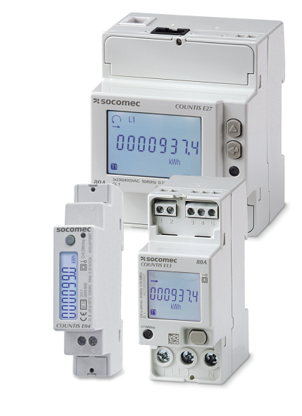
Ultra-communicative metres
Communication is one of the COUNTIS E range's main strengths. Existing metres already offered a number of possibilities: pulse output, Modbus ports or M-Bus.
The new E17, E18, E27 and E28 models are fitted with Ethernet communication ports and an integrated single-point web server. Thanks to a simple Internet browser, users can configure their measuring device, monitor electrical quantities, and view and export data pertaining to consumed energy.
For applications that integrate multiple measuring points, the Diris G gateway grants access to a multipoint web server, to ensure data monitoring and integration for up to 32 measurement devices.

Re-invoicing energy in total peace of mind
Just like for existing COUNTIS E models, each new model is available in a "B+D module" MID-certified version, that ensures precise and reliable measurements. Users are now offered an adapted solution within the COUNTIS E range for re-invoicing consumed energy via an application, regardless of the electrical network (single- or three-phase), communication protocol and charge current. In addition, tamper-proofing accessories prevent any fraudulent activity and ensure the installation's completeness.

Faster commissioning and configuration
COUNTIS E devices are protected against phase/neutral reversals, thus guaranteeing good function and reducing the number of checks required upon commissioning.
The new models - fitted with single-point web servers - can easily be configured from an Internet browser. For other models, the Easy Config software is an extremely simple solution for creating, modifying and saving your configuration.

Multi-pricing and multi-measurement solutions
Practically all references within the range of COUNTIS E meters offer a multi-pricing measurement function; this means they can either measure energy consumption during various time slots, or measure energy originating from various sources (normal, backup). They can display up to 20 electrical quantities at a time.

Improved performance levels
The launch of these new models triggered an enhancement of existing models: maximum input current for COUNTIS E03 and E04 devices has increased from 32 to 40 A, and that of COUNTIS E23, E24, E25 and E26 models from 63 to 80 A.
COUNTIS E13, E14, E15 and E16 models now boast the more compact design already present in E17 and E18 versions: they are now delivered in a "2 module"-sized DIN rail box.

Electrical energy, but not only...
Remember that the COUNTIS E range also includes the ECi2 and ECi3 multi-fluid pulse concentrators, which collect and store pulses stemming from water, gas, compressed air or electricity metres, or even analogue sensors (light, temperature, wind, etc.), in real time.

Compliance with standards
COUNTIS E devices meet the requirements set out in:
- IEC standard 62053-21 (active energy),
- IEC standard 62053-23 (reactive energy),
- IEC standard 62053-31,
- IEC standard 62053-11,
- EN standard 50470-1,
- EN standard 50470-3,
- Thermal regulation RT 2012,
- ISO standard 50001.

COUNTIS E devices exist in a "B+D module" MID-certified version.

Important information
- Active and reactive energy metres (direct measurement up to 100 A and current transformer up to 6,000 A) on single- and three-phase networks
- Multi-protocol communication: Modbus, M-Bus, Ethernet
- Fast commissioning and configuration
- MID version for tamper-proof measurements

For further information about COUNTIS E.

ABOUT SOCOMEC |  | MORE INFORMATION
Founded in 1922, SOCOMEC is an independent, industrial group with a workforce of 3100 people spread over 27 subsidiaries in the world. Our core business – the availability, control and safety of low voltage electrical networks with increased focus on our customers’ power performance. In 2016, SOCOMEC posted a turnover of 480 M€. |  | Press contact  Virginie GUYOT  Offer Communication Manager  Tel: +33 (0)3 88 57 78 15  Email: virginie.presse@socomec.com  www.socomec.com

