New range of scalable UPS up to 2.4 MW from SOCOMEC, entirely designed and manufactured in Europe

Benfeld, 3rd April 2017
A leader in the development and manufacture of large integrated UPS systems (Uninterruptible Power Supplies), SOCOMEC is proud to present several new scalable and energy-efficient solutions. The equipment combines the advantages of the Green Power 2.0 technology and the flexibility of a modular system.

Power adapted to demand
The rapid technological changes in IT systems mean that the electrical supply infrastructure needs to be increasingly adaptable and responsive. Ease of upgrading has become crucial to ensure the power supply in the short term and the adaptation in the long term of many electrical facilities. And there is a further advantage to having scalable systems: they allow quick deployment at a better cost.

DELPHYS Xtend GP – scalable hot-swap UPS systems up to 2.4 MW
DELPHYS Xtend GP is a UPS system whose total power output can be upgraded by the addition of power blocks in order to meet increases in load demand. The system allows the electrical facility to evolve without any impact on the existing infrastructure. During power upgrades or during servicing of the blocks, the load remains completely protected by the double conversion (“on-line” mode).
DELPHYS Xtend GP is the innovative solution for protecting critical loads, especially:
- large data centres,
- large telecom infrastructures,
- healthcare buildings,
- and more generally, any service or industrial applications that have many loads.
The “hot-scalability” or “hot-swap” function means the total power of the system can be upgraded without interruption to service continuity, within the limits of the requirements initially stated by the customer. Total power can thus reach 2400 kW by the addition of 200 kW modules. This function is assured by pre-wired units (Xbays) that connect or disconnect the power blocks (Xmodules) without modifying the surrounding electrical infrastructure. Even when complete, the system remains open to future evolutions.

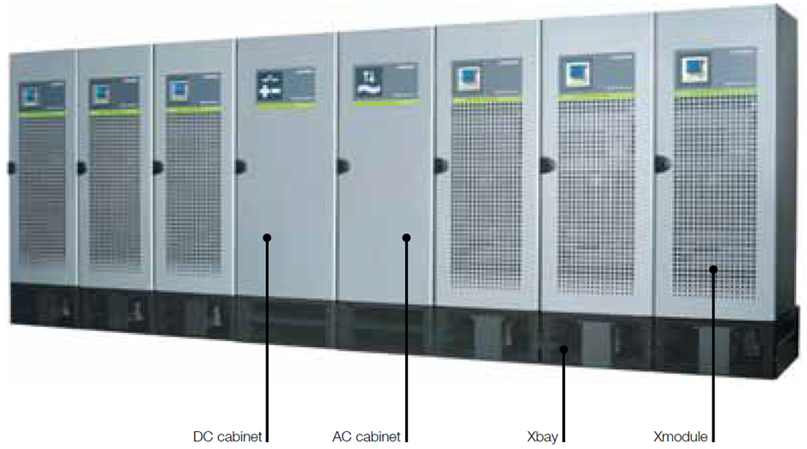

Easy to install and implement, the system ensures safety during servicing operations, for both technical operators and users.
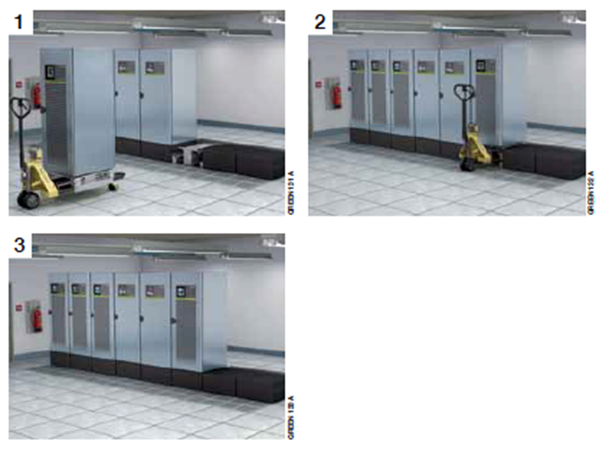

Power upgrades are done via the addition of hot-swap cabinets.

Based on a concept of flexible “bricks”, the DELPHYS Xtend GP system adapts to any type of infrastructure and environment.

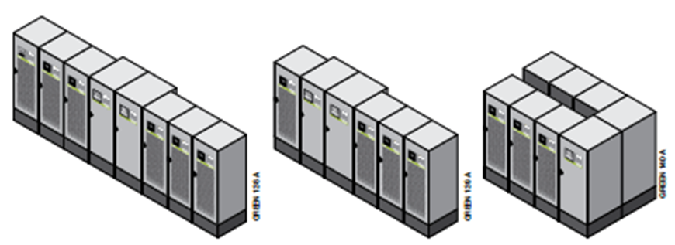

To check its back-up function and its correct operation, the DELPHYS Xtend GP UPS integrates a BCR function (Battery Capacity Re-injection) that tests the level of charge it the battery. This function, developed by SOCOMEC is an especially interesting innovation that provides cost savings (reduced TCO): simplified infrastructure, energy savings, faster programming, etc.

MODULYS GP - modular UPS from 25 to 600 kW
Another scalable UPS solution with the Green Power 2.0 technology is the MODULYS GP range. The principle is the same: the power output can be scaled up to 600 kW via the addition of 25 kW hot-swap plug-in power modules that are stacked vertically within the cabinets.
Designed with no single point of failure, the MODULYS GP range provides total redundancy of N+1 or N+x. The fully integrated solutions from 25 to 400 kW and from 25 to 600 kW allow a complete, simple and very reliable installation, with unique IN/OUT and fully sized manual bypass.
The MODULYS GP UPS provide a highly available power supply solution for critical applications present technical IT rooms, data centres, banks, healthcare establishments, insurance companies and telecommunications. With two levels of extension available, the user can meet unpredictable power demand at the best cost.

MODULYS RM GP - a modular UPS system for integration in 19" racks
The quality of the MODULYS GP is now also accessible for users who want to integrate the UPS function in existing 19” racks.
MODULYS RM GP is a three-phase UPS system for protecting critical loads has been specially designed to be incorporated into 19” rack cabinets. It can comprise up to 4 modules of 25 kW.
Easy to integrate, use and service, it is extremely compact and leaves sufficient space for other devices to be mounted on the racks.

Green Power 2.0
The UPS solutions using the Green Power 2.0 technology offer the same advantages:
- Output efficiency of up to 96%,
- Reduced power bills and cooling costs when operating in VFI mode,
- Unitary Power Factor (PF = 1) that ensures an excellent euro / kW ratio,
- Levels of performance certified by Bureau Veritas.

Conformity to standards
The entire Green Power 2.0 range complies with the recommendations set out in the European Code of Conduct (CoC) governing data centres in order to reduce energy consumption and greenhouse gas emissions. The range is also covered by a Product Environment Passport (PEP). All the ranges mentioned above are designed, tested and manufactured in Europe.

Key points
- Delphys Xtend GP: hot-swap power upgrades up to 2.4 MVA/MW
- Modulys GP: scalable up to 600 kVA/kW
- Modulys RM GP: scalable up to 4x25 kVA/kW
- All the advantages of the Green Power 2.0 technology
- Designed and manufactured in Europe

ABOUT SOCOMEC |  | MORE INFORMATION
Founded in 1922, SOCOMEC is an independent, industrial group with a workforce of 3100 people spread over 27 subsidiaries in the world. Our core business – the availability, control and safety of low voltage electrical networks with increased focus on our customers’ power performance. In 2016, SOCOMEC posted a turnover of 480 M€. |  | Press contact  Virginie GUYOT  Offer Communication Manager  Tel: +33 (0)3 88 57 78 15  Email: virginie.presse@socomec.com  www.socomec.com

