Note : Upgrading the DIRIS A-40 Ethernet
Date : 13/05/2019 | From :MKG PSM

There is a temporary problem to upgrade the Ethernet card of the DIRIS A-40 Ethernet version due to a bug in the bootloader on the main card.

These steps are to be carried out until PUT is improved to manage only one package.

Step 1 : Ethernet bootlader upgrade

Upload the package DIRIS-DIGIWARE-A40-1-BTL_PRODUCT-FIRMWARE_2019-05_PFW_MULTI with PUT:
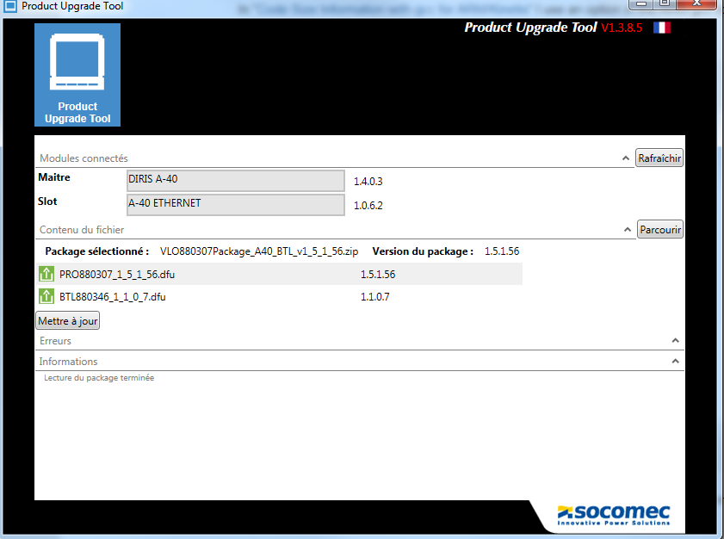

This package will upgrade the main card and the bootloader of the ethernet card.

Step 2 : Ethernet application upgrade

Upload the package DIRIS-DIGIWARE-A40-2_PRODUCT-FIRMWARE_2019-05_PFW_MULTI with PUT:
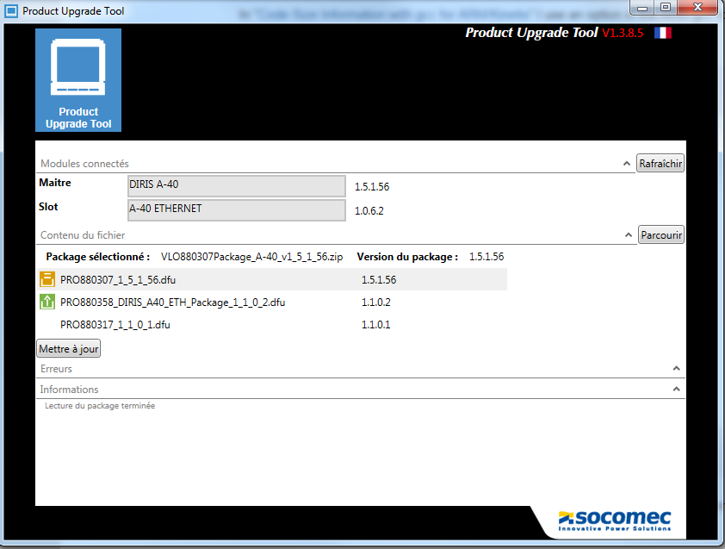

This package will update the Ethernet or Profibus card.
It also contains the dfu of the main card even if it has already been updated with the bootloader.

