New range of ATS controllers: versatile, intuitive and connected to manage your source changes

Benfeld, September 28th 2019
Socomec sets up the bases of their new ATS control strategy. Add force, speed and power to your transfer switch with this new complete line of controllers following the most exigent standards for control in installations. Safety, reliability and intuitivity as never seen before.

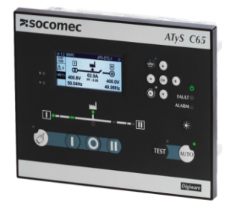
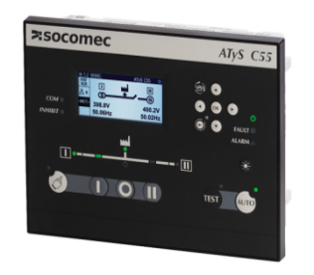
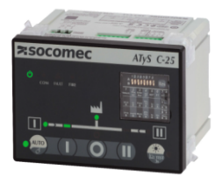
Reasons for investing in your ATS Controller
ATS are often set in a crucial path of the energy inside an electrical installation. They’re in between the sources and the loads and their function is crucial: to switch from one lost or unstable source to a backup source and guarantee the supply to critical loads.
While other controllers don’t ensure their capacity to be used at the distribution level, right after the main incomer, where an overvoltage category III is required by the installation standards, the new ATyS Cx5 range is not only ensuring CAT III but also higher isolation distances and voltage impulse withstand capabilities by conception that what the standard requires, ensuring a plus of safety and reliability in your installation.

The IEC 61010-2-201 standard for control equipment, as well as the GB/T 14048.11 annex C are some of the most strict standards for transfer switching control equipment that we should make sure our ATS Controller is compliant to when designing an electrical installation with several sources. They ensure the most severe test regarding electrical shock, mechanical stress, fire, heat, fluids and radiations.

Choose the right partner for Transfer Switching
Socomec's ATyS Cx5 range of ATS Controllers detect the sources unavailability, due to a power loss or a bad quality network, and pilots the switching device to transfer to the secondary source, usually a diesel generator. The switching device can be switch-based or be assembled with two contactor or circuit breakers (MCCB and especially ACBs) and have no intelligence; they will receive the orders from the controller, that will work as the brain of the transfer switch. The ATyS Cx5 range are compatible with all technologies and brands of switching devices available in the market.
After more than 60 years designing, manufacturing and testing transfer switch solutions, Socomec brings to the market the ultimate controller for transfer switching following the same guidelines than the other 5 generations of transfer switching equipment quality, safety and reliability. More than 3 million installations around the globe are already using a Socomec transfer switch. Benefiting from the experience of a globally known and recognized brand of transfer switches is a warranty for the installation; who better than an ATS expert to create an ATS controller?

A user-friendly solution
With a high definition display, able to show pop-ups, dashboards and graphs, the ATyS C65 has an easily navigable interface to make the operator’s interaction more intuitive than ever. The interface and display, as well as the menus, have been designed to simplify the configuration, operation and maintenance.
A dedicated smart configuration wizard will pop-up on the first power up to guide the installer on the commissioning, asking the main questions to leave the transfer switch configured and ready to work.
The dashboards can be access from the front face of the ATyS C65 and they allow the user to see the status of the sources in detail, power values and energy consumption, the user-configurable alarms, the timers settings and the optional functions used with the inputs and outputs, including the optional extension I/O that can be added plug & play to the controller, reaching a total of 30 inputs and 18 outputs.
The menus are available in 9 embedded languages. All configurations can be done through the display in a very easy way and the HMI counts with most of the main operator functions with a dedicated pushbutton, there’s almost no need of instruction manual. The controller also counts with its free configuration software and a webserver visualization software is provided with the communications gateway.

Cutting-edge performance
ATyS C65 boasts an array of features and is also designed to suit all facilities, no matter the type of source, loads and switching device. It features:
- Smart configuration wizard, saving installation time.
- 30 second energy backup when all sources are down, to keep its power and communications on until the genset is running.
- Alarm & event log up to 3000 records.
- Current measurement with standard /1A or /5A CT, power and energy consumption measurement.
- Fully configurable timers, thresholds and I/O with more than 40 different preset functions.
- Integrated Modbus RTU protocol and Diris Digiware compatibility. Ethernet, BACnet and SNMP through gateway.
- Four user customizable genset scheduler programs to start and run the genset with or without load periodically, exercising it to be ready when most needed.
- Smart load shedding, elevator control, HVAC compressor saver and other new functions to be selected on the 6 I/O the controller has or the 6 external optional I/O modules.

Compliance with standards
The ATyS C65 ATS Controller complies with:
- IEC standard 61000-1
- IEC standard 61010-6-2-201
- IEC standard 60947-6-1
- GB/T standard GB/T 14048.11

To remember
- Automatic transfer switch controller for ensuring power availability on critical applications
- Compliant IEC 61010-2-201, the most strict standard for ATS control
- The most intuitive in the market: smart configuration wizard, dashboards, pop-ups, clear menus.
- Compatible with all types of installation, no matter the sources, loads or switching device.

For further information about ATyS C65.

ABOUT SOCOMEC |  | MORE INFORMATION
Founded in 1922, SOCOMEC is an independent, industrial group with a workforce of 3100 people spread over 27 subsidiaries in the world. Our core business – the availability, control and safety of low voltage electrical networks with increased focus on our customers’ power performance. In 2016, SOCOMEC posted a turnover of 480 M€. |  | Press contact  Virginie GUYOT  Offer communication Manager  Tel: +33 (0)3 88 57 78 15  Email:  virginie.presse@socomec.com  www.socomec.com

