New: DIRIS Digiware R-60
Socomec launches a new module combining both residual current and load current monitoring

Specialists in power switching, energy conversion and measurement, the independent industrial group SOCOMEC has launched a new module for its DIRIS Digiware power monitoring system: the DIRIS Digiware R-60.
By combining the monitoring of residual currents and load currents, this innovative module allows to anticipate anomalies and RCD (Residual Current Device) trips within the electrical installation. This capability is a robust response to the challenges encountered by industrial sites and data centres – in particular, the need to guarantee continuity of service.

DIRIS Digiware R-60: a module dedicated to residual current monitoring (RCM)
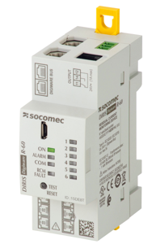

The DIRIS Digiware R-60 module primarily helps to anticipate anomalies. Indeed, notification of an increase in residual currents makes it possible to plan maintenance operations and shutdowns, therefore avoiding costly downtime.

Thanks to alarm notifications, the RCM module makes an important contribution to the safety of property and people by preventing critical situations such as service interruption or the risk of fire – all without interrupting the power supply.

Finally, thanks to the permanent installation of an RCM system that complies with the IEC 62020 product standard, the requirement to periodically verify the insulation resistance of each outgoing circuit - as required by the IEC 60364 standard and numerous national transpositions - becomes optional rather than mandatory.

Considering these features, the DIRIS Digiware R-60 module meets the specific requirements of industrial sites and data centres by preventing the interruption of production lines and the shutdown of computer servers respectively.

The DIRIS Digiware R-60 module will complement existing or new DIRIS Digiware measuring systems for a more global approach to the monitoring of an electrical installation.

DIRIS Digiware: a complete system for power monitoring

An innovative power monitoring system for AC and DC installations, DIRIS Digiware is a complete solution for monitoring the performance of an electrical installation. It is the only system combining energy sub-metering, power quality analysis and residual current monitoring. 100% customisable and scalable, this ecosystem meets the precise needs of each installation.

Suitable for both new and existing installations, the DIRIS Digiware system is particularly relevant within industrial and tertiary sectors as well as being ideally suited to data centre applications.

The DIRIS Digiware consists of the following modules:

- A communication interface (DIRIS Digiware D or M)
- A voltage acquisition module (DIRIS Digiware U or Udc)
- Current acquisition modules (DIRIS Digiware S, I or Idc)
- Solid core, split core or flexible current sensors (TE, TR/iTR or TF sensors)
- Residual current monitoring modules (DIRIS Digiware R-60) connected to residual CTs
- Digital and analogue input/output modules (DIRIS Digiware IO) for monitoring the position of protective devices and collecting pulses from multi-utility

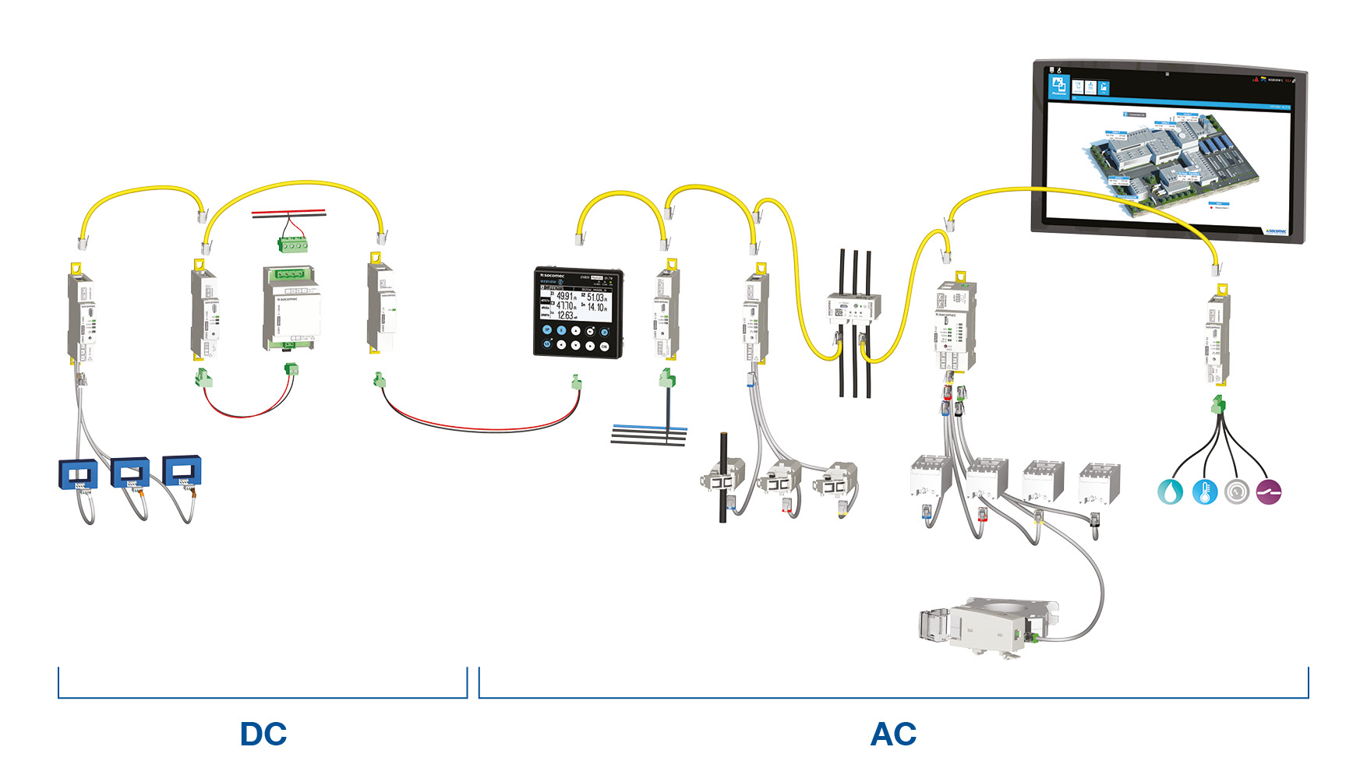

ABOUT SOCOMEC |  | MORE INFORMATION
Founded in 1922, SOCOMEC is an independent, industrial group with a workforce of 3100 people spread over 27 subsidiaries in the world. Our core business – the availability, control and safety of low voltage electrical networks with increased focus on our customers’ power performance. In 2016, SOCOMEC posted a turnover of 480 M€.  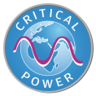 |  | Press contact  Virginie GUYOT  Offer communication Manager  Tel: +33 (0)3 88 57 78 15  Email:  virginie.presse@socomec.com  www.socomec.com

